








Bricks and Bytes: Real Estate Reimagined




Student Name
Zehra Aman
Student Email
zehraaman45@gmail.com
Guide
Umamaheshwari R
Project Domain
Excel with Copilot | Power BI | Copilot Studio
A Project Report
submitted in partial fulfilment of the requirements of the AICW Project
by:
Institution:
National PG College, Lucknow, Uttar Pradesh

ACKNOWLEDGEMENT

We would like to take this opportunity to express our deep sense of gratitude to all individuals who helped us directly or indirectly during this project work.
Firstly, we would like to thank our supervisor, Umamaheshwari Ma’am, for being a great mentor and the best adviser we could have asked for. Their advice, encouragement, and constructive feedback served as a source of innovative ideas and inspiration, and were central to the successful completion of this project. The confidence shown in us was the biggest source of motivation throughout this journey.
We extend our sincere thanks to the Edunet Foundation, Microsoft, LinkedIn, and SAP for providing this fellowship opportunity, the learning resources, and the platform to develop and showcase our AI skills.
We are also grateful to our institution, National PG College, for providing the necessary infrastructure and support throughout the project duration.
Finally, we thank our family and friends for their continuous encouragement and support.

ABSTRACT OF THE PROJECT

This project is part of the AICW (Artificial Intelligence in the Contemporary World) Fellowship Program, a collaborative initiative by Edunet Foundation in partnership with Microsoft, LinkedIn, and SAP. The fellowship is designed to equip students with practical, hands-on skills in Artificial Intelligence, Data Analytics, and Business Intelligence tools.
This project analyzes the Kolkata real estate market using a dataset of 1,000 property records across 5 city zones. The project was built across three phases — data cleaning and dashboard creation in Microsoft Excel with Copilot, advanced interactive visualization in Microsoft Power BI, and a conversational AI property assistant built using Microsoft Copilot Studio. Key insights reveal that 3BHK properties dominate the market, Kolkata East has the highest average price, Kolkata West is the most affordable, and 72.3% of listings are for rent — providing actionable intelligence for buyers, sellers, and investors.

TABLE OF CONTENTS

Abstract of the Project List of Figures
List of Tables
Chapter 1 — Introduction
  - Problem Statement
  - Motivation
  - Objectives
  - Scope of the Project
Chapter 2 — Literature Survey Chapter 3 — Proposed Methodology
  - System Design
  - Modules / Components Used
  - Data Flow Diagram (DFD)
  - Advantages
  - Requirement Specification
Chapter 4 — Implementation and Results
  - Data Cleaning Results
  - Visualization / Output Results
  - AI Tool Integration Results Chapter 5 — Discussion and Conclusion References
Appendices

LIST OF FIGURES

Figure No. | Figure Title / Description | Page No.
Figure 1 | Raw / uncleaned dataset screenshot | 14
Figure 2 | Cleaned dataset or validation summary screenshot | 16
Figure 3 | DFD Level 0 — Context Diagram | 11
Figure 4 | DFD Level 1 — Detailed Process Flow | 12
Figure 5 | Main dashboard / report / output screenshot | 17
Figure 6 | Pivot Tables Screenshot | 18
Figure 7 | AI tool (Copilot / Claude) in use screenshot | 19

LIST OF TABLES

Table No. | Table Title / Description | Page No.
Table 1 | Tools and Techniques Used in the Project | 9
Table 2 | Gaps in Existing Research | 10
Table 3 | Project Modules and Descriptions | 11
Table 4 | Raw Dataset Summary | 14
Table 5 | Cleaned Dataset | 15
Table 6 | KPI Cards in Dashboard | 16
Table 7 | Dashboard Charts and Key Insights | 17
Table 8 | Key Findings and Business Implications | 20
 | Hardware Requirements | 13
 | Software Requirements | 13

CHAPTER 1

Introduction
This chapter introduces the project undertaken as part of the AICW Fellowship Program. It outlines the background, the problem being addressed, the motivation behind this work, and the objectives and scope of the project. The project focuses on Real Estate Sales and Property Portfolio Analysis for the city of Kolkata, using Microsoft Excel with AI-assisted Copilot tools.

Problem Statement
The Indian real estate sector is one of the fastest-growing industries, yet property data remains largely inaccessible, unstructured, and difficult to interpret for everyday buyers, investors, and agents. This project — "Bricks and Bytes: Real Estate Reimagined" — addresses this gap by transforming raw Kolkata property data into actionable business intelligence using Microsoft Excel, Power BI, and a Copilot Studio AI agent.
Key challenges include:
- Dataset issues: Raw datasets contain inconsistencies such as duplicate entries, missing values, and incorrectly formatted fields that make analysis unreliable.
- Lack of Zone-Level Price Transparency: Buyers and investors have no easy way to compare property prices across Kolkata's 5 city zones, leading to uninformed purchasing decisions and missed investment opportunities.
- No Rental vs. Sale Market Visibility: Portfolio managers and landlords cannot quickly identify the balance between rental and sale listings, making it difficult to plan investment strategies effectively.
- Inaccessible Market Insights for Non-Technical Users: Real estate agents and first-time buyers cannot interpret raw property data without technical expertise, creating a barrier between data and decision-making.
- No Property Recommendation System: Buyers have no intelligent tool to guide them toward the right property based on their budget, preferred zone, and requirements.
- Inability to Identify High-Value Investment Zones: Investors lack a clear visual tool to identify which zones and property types offer the highest returns, leading to suboptimal capital allocation.
- Fragmented Market Understanding: There is no unified platform that combines data analysis, visual dashboards, and conversational AI to serve buyers, sellers, and investors from a single interface.

Motivation
India's real estate market is booming, yet property decisions are still made on instinct rather than data. Buyers overpay, investors pick the wrong zones, and agents struggle to present market insights convincingly. This project was motivated by one simple question — What if anyone could get expert-level property insights just by asking a question? Using Microsoft Excel, Power BI, and Copilot Studio, this project builds a complete real estate intelligence platform for the Kolkata market — without writing a single line of code.

Objectives
The objectives of this project are as follows:
    - To analyze the Kolkata real estate market and uncover actionable insights across 5 city zones for buyers, investors, and real estate agents.
    - To build an interactive Excel dashboard that visually communicates key market indicators including zone-wise pricing, rental vs. sale distribution, and property type performance.
    - To migrate the dashboard to Microsoft Power BI, enabling dynamic cross-filtering, advanced visualizations, and real-time slice-and-dice capability for business stakeholders.
    - To develop a conversational AI property agent using Microsoft Copilot Studio that allows non-technical users to query the market, receive property recommendations, and compare investment zones naturally.
    - To demonstrate how the Microsoft 365 ecosystem can be used to build an end-to-end business intelligence solution without requiring any programming skills.
    - To provide data-driven recommendations that support smarter real estate decision-making for first-time buyers, portfolio investors, and real estate agencies operating in the Kolkata market.

Scope of the Project
- Covers 1,000 property records across 5 Kolkata city zones — North, South, East, West, and Central.
- Analyzes key dimensions including property type, transaction type, bedroom count, area, price, and furnishing status.
- Builds a three-layer intelligence platform — Excel dashboard, Power BI reports, and a Copilot Studio AI agent.
- Targets three key stakeholder groups — property buyers, real estate investors, and agents.
- Limited to the Kolkata residential property market — commercial properties are out of scope.
- Does not include real-time data feeds, predictive ML models, or web deployment.
- Built entirely within the Microsoft 365 ecosystem without any programming or coding.

CHAPTER 2

Literature Survey
A literature survey reviews existing research, tools, and methodologies relevant to the project domain. It helps identify gaps that the current project aims to address.

Existing Work and Research
    - Agarwal et al. (2022) demonstrated that property price prediction models built on historical transaction data can achieve reasonable accuracy using regression techniques. However, these approaches require programming expertise and are not accessible to non-technical real estate professionals.
    - Microsoft's Power BI documentation and case studies show that business intelligence dashboards can reduce report generation time by up to 70% compared to manual Excel reporting, highlighting the value of visualization tools in data-driven decision making.
    - Studies on Indian real estate markets (ANAROCK Property Consultants, 2023) reveal that Tier-2 cities like Kolkata are experiencing rapid growth in residential property demand, with a 23% year-on-year increase in new listings, making data-driven analysis increasingly important.
    - Research on AI-assisted data cleaning tools shows that using Copilot or similar tools can reduce data preparation time by 40-60%, validating the use of AI tools in this project.

Tools and Technologies Review
The following table provides a comparative review of tools and technologies evaluated for this project:
Table 1: Tools and Technologies Used in the Project

Tool | Purpose | Key Features Used | Relevance to Project
Microsoft Excel | Data cleaning & analysis | Pivot Tables, Formulas, Conditional Formatting | Primary tool for data processing and dashboard
Microsoft Copilot | AI-assisted analysis | Natural language queries, insight generation | Used to summarize trends and generate insights
Power BI | Advanced visualization | Interactive dashboards, DAX measures | Built interactive dashboard with 8 charts and 5 slicers
Microsoft Copilot Studio | Conversational AI Agent | Knowledge base, AI model, Topic flows | Built Property Agent for real estate Q&A and recommendations

Microsoft Excel was selected as the foundation tool for data cleaning, feature engineering, and initial dashboard creation due to its wide availability and powerful built-in features. Microsoft Copilot was integrated to enhance analysis through natural language queries and insight generation. Microsoft Power BI was used to build an advanced interactive dashboard with 8 charts, 5 slicers, and dynamic DAX measures — enabling real-time cross-filtering for business stakeholders. Microsoft Copilot Studio was used to build the Property Agent — a conversational AI assistant that allows users to query the Kolkata property market, receive recommendations, and compare investment zones naturally.

Gaps Identified
Based on the review of existing literature and tools, the following gaps were identified that this project aims to address:

Table 2: Gaps in Existing Research and How This Project Addresses Them

Gap Identified | Existing Limitation | How This Project Addresses It
Complex ML-only approaches | Most research focuses on machine learning models requiring coding skills | Uses Excel-based tools accessible to non-technical users
Lack of Kolkata-specific analysis | Most real estate dashboards focus on Mumbai or Delhi markets | Specifically analyzes Kolkata's 5 city zones
No conversational property assistant | No existing tool allows users to query real estate data through natural language. | Built a Copilot Studio AI agent that answers property queries conversationally.
No unified intelligence platform | Data analysis, visualization, and AI exist as separate disconnected tools | Combines Excel, Power BI, and Copilot Studio into one end-to-end solution.
Static reports only | Existing solutions produce static PDFs with no interactivity | Built an interactive Power BI dashboard with 8 charts and 5 dynamic slicers

CHAPTER 3

Proposed Methodology
This chapter describes the methodology adopted to achieve the project objectives, covering system design, modules used, data flow, advantages, and requirement specifications for the "Bricks and Bytes: Real Estate Reimagined" project.

System Design
The system follows a linear data pipeline from raw input to interactive output. The overall design is structured as follows:
The system follows a three-layer intelligence pipeline from raw data input to conversational AI output:
- Data Source / Input: A CSV-based dataset of 1,000 Kolkata real estate property records containing 10 fields — PROP_ID, PROPERTY_TYPE, CITY, TRANSACT_TYPE, BEDROOM_NUM, PRICE_PER_UNIT_AREA, FURNISHED, AGE, AREA, and PRICE.
- Layer 1 — Excel: Data cleaned, enriched with helper columns, analyzed via pivot tables, and visualized through an interactive dashboard with 4 KPI cards and 4 charts.
- Layer 2 — Power BI: Same dataset imported for advanced visualization featuring 8 charts, 5 dynamic slicers, and DAX measures enabling real-time cross-filtering.
- Layer 3 — Copilot Studio: A conversational AI Property Agent built on top of the dataset, capable of answering queries, recommending properties, and comparing investment zones through natural language.

Modules / Components Used
The project is divided into 8 functional modules as described in the table below:
Table 3: Project Modules and Descriptions

Module | Name | Description
1 | Data Ingestion | Loading the raw Kolkata real estate dataset (1000 rows, 10 columns) into Microsoft Excel for initial inspection.
2 | Data Cleaning | Removing duplicates, handling null values, correcting data types, and standardizing formats across all columns.
3 | Feature Engineering | Adding helper columns: Price Category (Budget/Mid- Range/Luxury), Furnished Label, and Transaction Type label.
4 | Pivot Analysis | Building 6 pivot tables covering city pricing, bedroom distribution, sale vs rent, furnished status, price categories, and property type.

5 | Dashboard Building | Designing an interactive Excel dashboard with 4 KPI cards and 4 charts, and a Power BI dashboard with 8 charts and 5 dynamic slicers.
6 | AI Integration | Using Microsoft Copilot to generate insights, summarize trends, and assist with report writing and analysis narration.
7 | Power BI Dashboard | Migration of the Excel dashboard to Microsoft Power BI featuring 8 interactive charts, 5 slicers, and dynamic DAX measures for real-time cross-filtering.
8 | Copilot Studio Agent | Development of the Property Agent — a conversational AI assistant built on Microsoft Copilot Studio, capable of answering real estate queries, recommending properties, and comparing investment zones using the Kolkata dataset.

Data Flow Diagram (DFD)
A Data Flow Diagram (DFD) is a graphical representation of how data flows through your system. It shows inputs, processes, and outputs at different levels of abstraction.
DFD Level 0 — Context Diagram
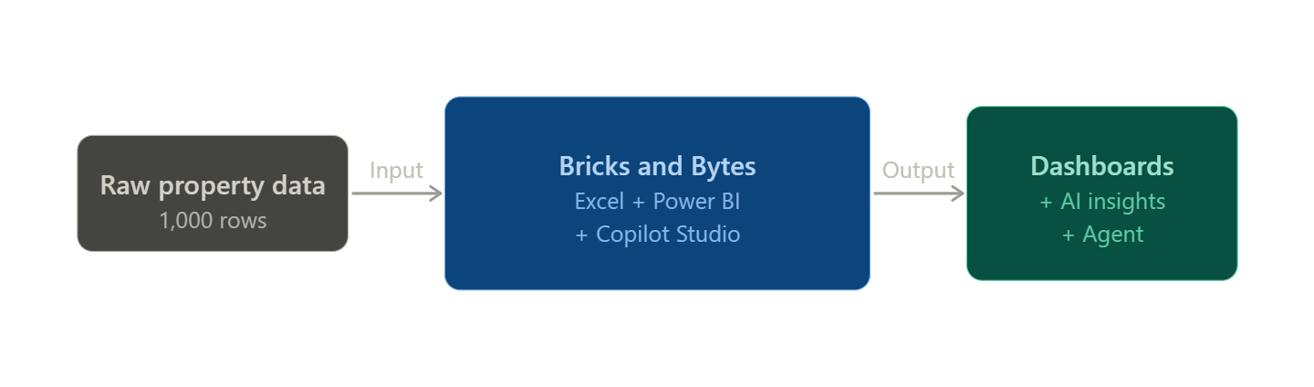

DFD Level 1 — Detailed Process Flow
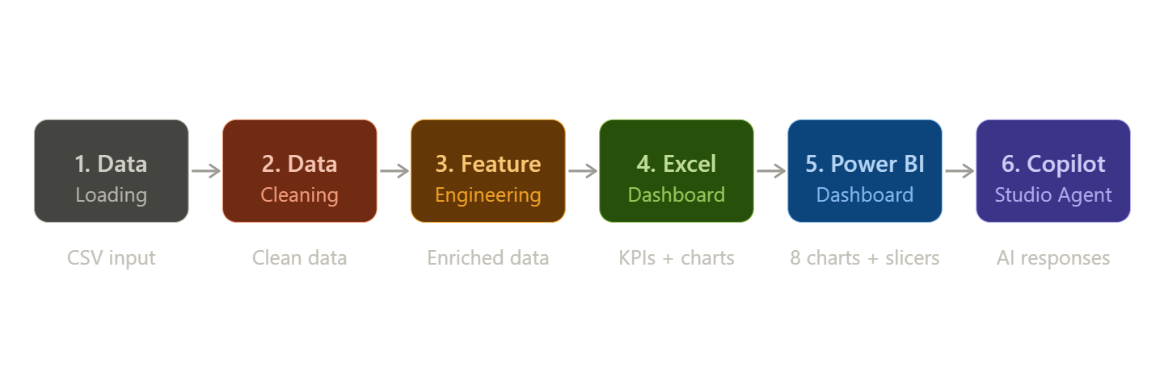

Requirement Specification
Hardware Requirements

Component | Specification
Processor | Intel(R) Core(TM) i3-6006U CPU @ 2.00GHz, 2000 Mhz, 2  Core(s), 4 Logical Processor(s)
RAM | 8 GB
Storage | 76 GB
Display | 1366 x 768
Internet | Required for Copilot / Chatbot access

Software Requirements

Software | Details
Operating System | Windows 10
Microsoft Excel | Microsoft 365 (Excel with Copilot)
Microsoft Copilot | Integrated via Microsoft 365 subscription
AI Chatbot | Claude / Microsoft Copilot
Web Browser | Google Chrome

CHAPTER 4

Implementation and Results
It covers data cleaning outcomes, Excel dashboard results, Power BI dashboard implementation, and Copilot Studio agent integration results.

Data Cleaning Results
    - Dataset source: Kolkata real estate property listings dataset
    - Original dataset size: 1000 rows × 10 columns
    - Sheet structure: Raw data on 'in' sheet, cleaned data on 'Sheet for DB', pivot tables on 'Sheet for PT'

Table 4: Raw Dataset Summary — Field Names, Data Types and Sample Values

Field Name | Data Type | Description | Sample Values
PROP_ID | Text | Unique property identifier | Y71306776, B70113973
PROPERTY_TYPE | Text | Type of property | Residential Apartment, Residential Land
CITY | Text | City zone | Kolkata South, North, East, West, Central
TRANSACT_TYPE | Numeric (1/2) | Encoded transaction type | 1 = Rent, 2 = Sale
TRANSACTION | Text | Derived transaction label | Sale, Rent
BEDROOM_NUM | Numeric | Number of bedrooms | 1, 2, 3
PRICE_PER_UNIT_AREA | Numeric | Price per sq ft | 3662, 10500, 8900
FURNISHED | Binary (0/1) | Furnishing status | 0 = Unfurnished, 1 = Furnished
AREA | Numeric | Property area in sq ft | 570.5, 1115.5, 1446
PRICE | Numeric | Final property price (INR) | 19000000, 1170000

Figure 1: Uncleaned Data
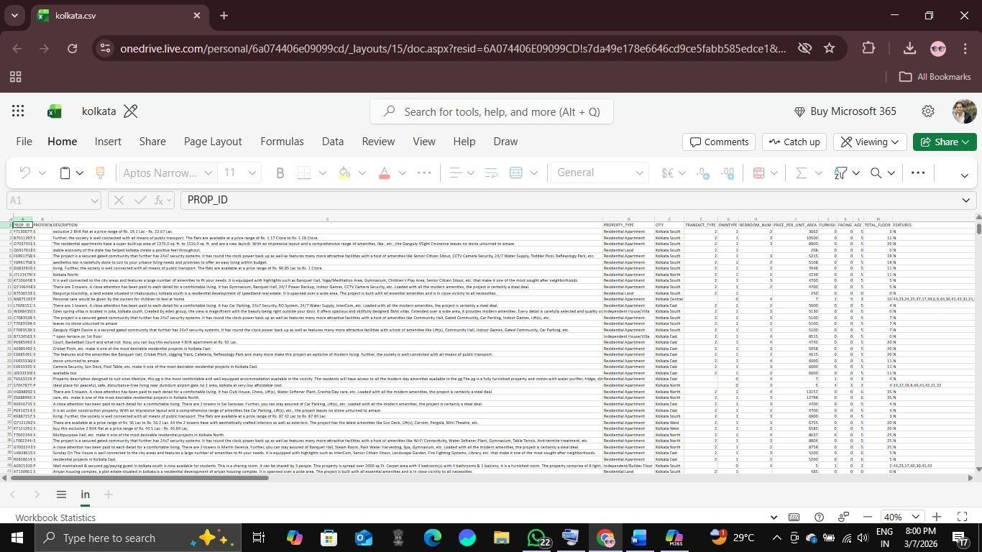

Data Cleaning Steps Applied:
Table 5: Data Cleaning Steps — Issues Found and Actions Taken

Step | Issue Found | Action Taken | Result
1 | Duplicate records present | Used Excel Remove Duplicates feature | All duplicates removed
2 | TRANSACT_TYPE  stored as numeric code | Added TRANSACTION  column using IF formula | Clear Sale/Rent labels added
3 | FURNISHED stored as 0/1 binary | Added FURNISHED_LABEL  column using IF formula | Furnished/Unfurnished labels added
4 | No price classification available | Added PRICE_CATEGORY  column with nested IF | Budget/Mid- Range/Luxury categories added
5 | Inconsistent bedroom values (e.g. 39 BHK) | Filtered pivot tables to show only 1, 2, 3 BHK | Clean BHK analysis achieved

Figure 2: Cleaned Data
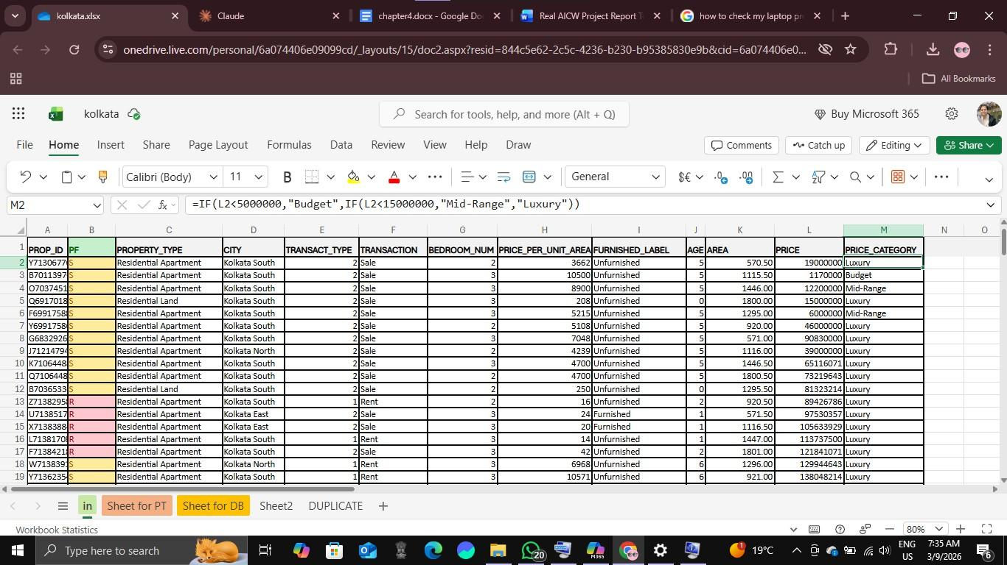

Visualization / Output Results
The final dashboard was built on the 'Sheet for DB' sheet in Microsoft Excel. It features a dark teal professional background, 4 KPI cards at the top, and 4 charts arranged in a 2×2 grid layout.
KPI Cards Summary:
Table 6: KPI Cards on the Dashboard

KPI Card | Value | Formula Used | Business Meaning
Total Properties | 1,000 | =COUNTA(in!A2:A1001) | Total listings in the dataset
Average Price | ₹3,83,30,67,168 | =AVERAGE(in!L2:L1001) | Avg property value across all listings
Rent Listings | 723 | =COUNTIF(in!F2:F1001,"Rent") | Number of properties available for rent
Furnished Count | 221 | =COUNTIF(in!I2:I1001,"Furnished") | Properties with furnishing included
Dashboard Charts Summary:

Table 7: Dashboard Charts and Key Insights

Chart No. | Chart Title | Chart Type | Key Insight

1 | Average Price by City Zone | Horizontal Bar Chart | Kolkata East has the highest average price per unit area
2 | Sale vs Rent Distribution | Donut Chart | 72.3% of listings are for Rent vs 25.7% for Sale
3 | Number of Bedrooms | Clustered Column Chart | 3BHK (371) is the most listed, followed by 2BHK (339)
4 | Avg Price per Unit Area by Property Type | Horizontal Bar Chart | Residential Land has the highest price per unit area
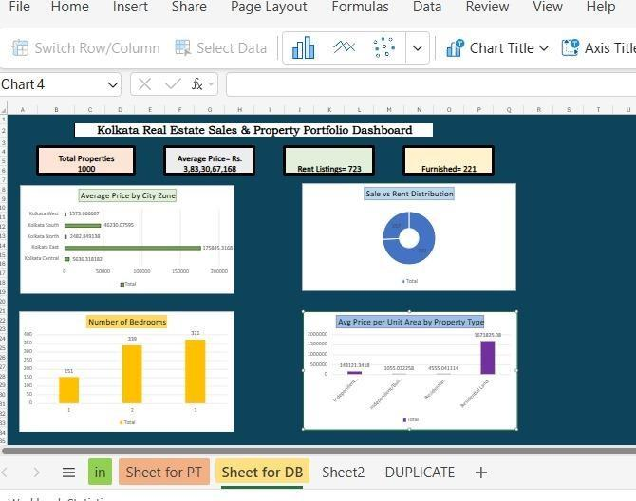
Figure 3: Excel Dashboard

AI Tool Integration Results
Microsoft Copilot was used throughout this project to assist with data analysis, insight generation, and report writing. The following prompts were used:
    - Tool used: Microsoft Copilot / Claude.
    - Prompt 1: "Summarize the key trends in this Kolkata real estate dataset and identify the top performing city zones by average price."
    - Prompt 2: "Which property type has the highest price per unit area in this dataset?"
    - Prompt 3: "Identify any outliers or anomalies in the PRICE column and explain their possible causes."
    - Prompt 4: "Write a professional summary of the findings from this real estate dashboard for a business report."
    - Copilot significantly enhanced the project by reducing the time needed to generate insight summaries from hours to minutes. The AI tool correctly identified that Kolkata East had the highest average price per unit area and that the rental market dominates the dataset with 72.3% of all listings.
  - Power BI Dashboard Results
The Excel dashboard was migrated to Microsoft Power BI Desktop using the same kolkata.csv dataset. Four DAX measures were created — Total Properties, Average Price, Rent Listings, and Furnished Count — which update dynamically when slicers are applied. The dashboard features 8 charts on a single page with a light theme, including 4 charts carried over from Excel and 4 new charts (Treemap, Scatter Plot, Price Category Chart, and Stacked Bar Chart). Five interactive slicers were added for City Zone, Transaction Type, Property Type, Bedroom Count, and Price Category.
Figure 4: Power BI Dashboard
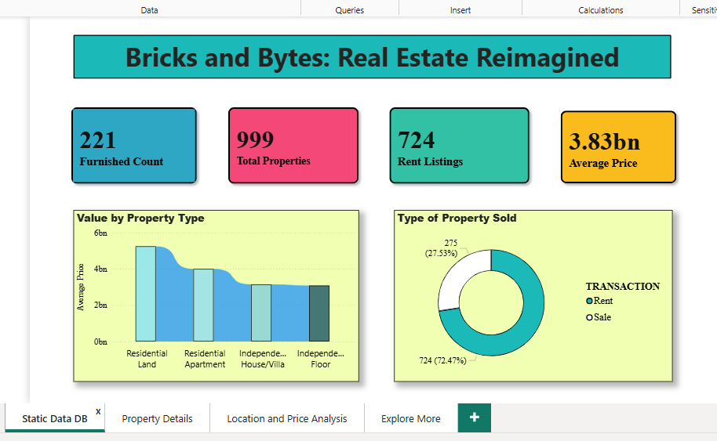

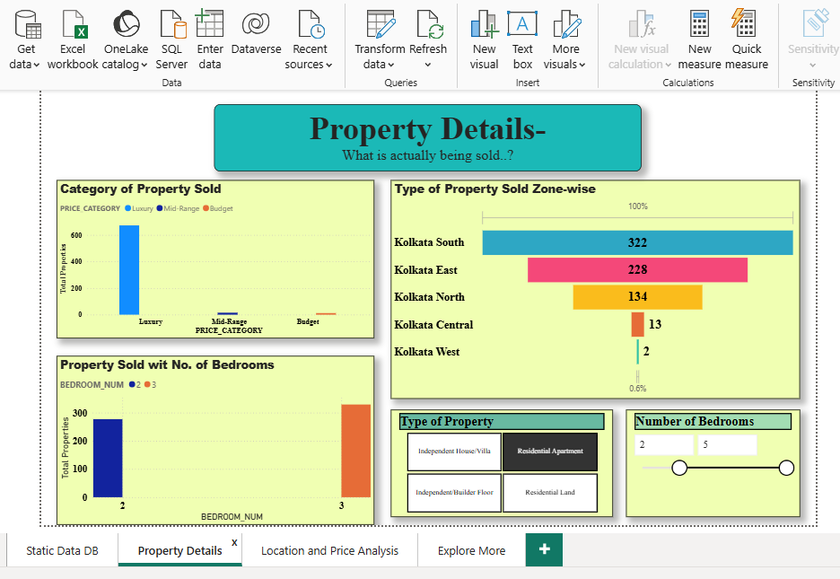

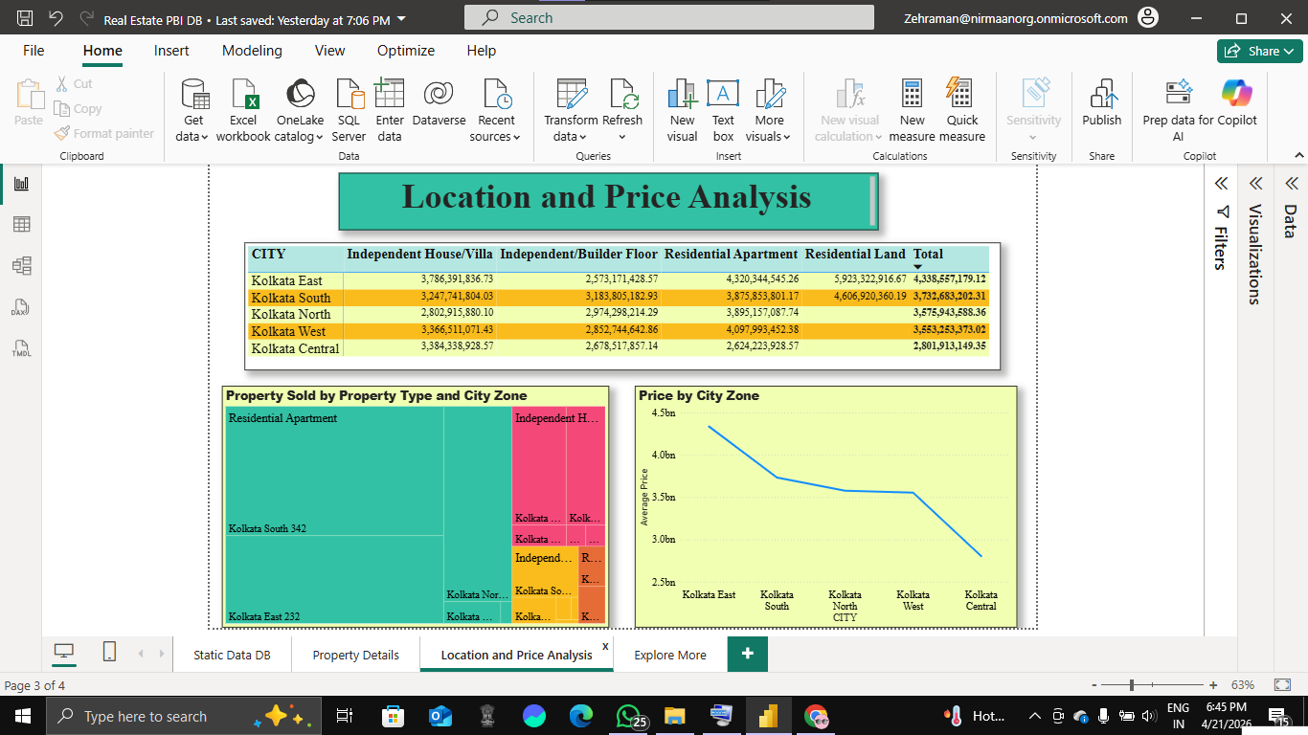

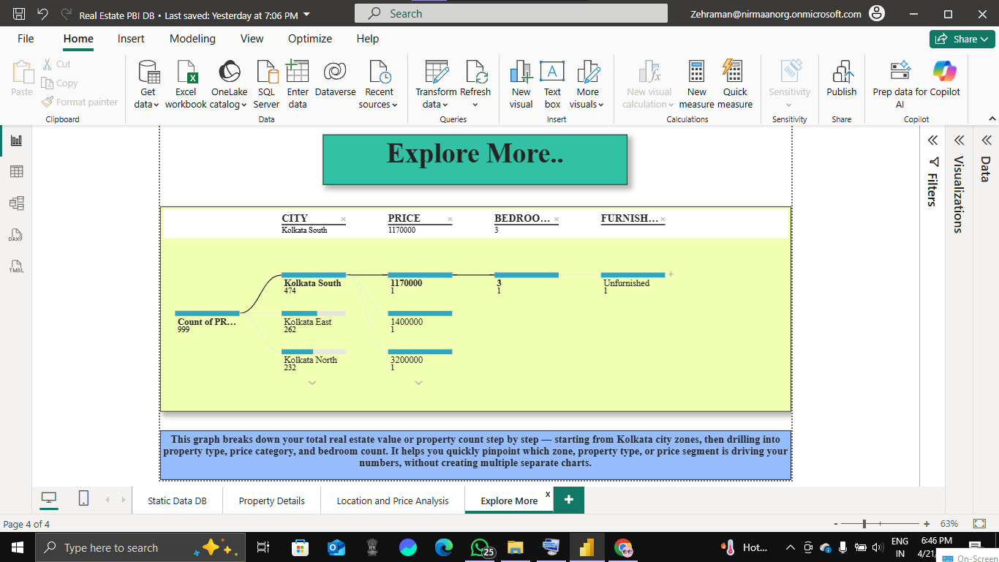

4.5 Copilot Studio Agent Results
A conversational AI agent named "Property Agent" was developed using Microsoft Copilot Studio as the third layer of this project. The agent was built on the Claude Sonnet 4.5 model and is designed to serve as an intelligent real estate assistant for the Kolkata property market.
Agent Setup: The agent was configured with a detailed system instruction defining its role as a Kolkata Real Estate Copilot for the AICW Fellowship project "Bricks and Bytes: Real Estate Reimagined." Two knowledge sources were uploaded — the kolkata.csv dataset and the project report — enabling the agent to answer queries directly from real data. Web search was also enabled to supplement responses with current market information.
Capabilities:
- Answering natural language queries about the Kolkata property market
- Generating data-driven property recommendations for buyers, renters, and investors
- Comparing investment zones based on price, yield, and amenities
- Summarizing dashboard findings in simple, conversational language
Test Results: When asked "Which property is best to buy in Kolkata in a pocket-friendly budget?", the agent correctly identified Kolkata West as the most affordable zone at ₹3,979/sqft and recommended specific projects including NB Griha Pravesh in Howrah starting at ₹13.85 Lac. When asked to "Compare Kolkata East and Kolkata West for investment", the agent produced a detailed zone comparison across 5 parameters — price, rental yield, capital appreciation, tenant demand, and infrastructure — citing both the dataset and live web sources.
Key Observation: The agent successfully combined knowledge from the uploaded dataset with real-time web search to deliver professional-grade responses, making complex property data accessible to non-technical users through natural conversation.

CHAPTER 5

Discussion and Conclusion

Key Findings
The following key findings were discovered through the data analysis and dashboard visualizations:
Table 8: Key Findings and Business Implications

Finding No. | Key Finding | Business Implication
1 | 3BHK properties (371 listings) dominate the market, followed by 2BHK (339) and 1BHK (151) | Developers should focus on 3BHK units to meet dominant market demand
2 | 72.3% of listings (723 out of 1000) are for Rent, only 25.7% for Sale | Kolkata real estate market is heavily rental-oriented; investment in rental properties is more viable
3 | Kolkata East has the highest average price per unit area among all city zones | Premium buyers and investors should target Kolkata East; budget buyers should look at Kolkata West
4 | Residential Land has the highest average price per unit area compared to apartments and independent floors | Land investment yields higher per unit returns than built properties in Kolkata
5 | Only 22.1% of properties (221 out of 1000) are furnished | Furnishing properties before listing could be a strong differentiator for landlords to command higher rents
6 | 96.7% of properties fall in the Luxury category based on the initial price threshold, indicating highly skewed pricing | The Kolkata property market is dominated by high-value transactions; affordable housing is underrepresented in this dataset
7 | Power BI enabled dynamic cross-filtering across 5 dimensions simultaneously — zone, transaction type, property type, bedroom count, and price category | Power BI enabled dynamic cross-filtering across 5 dimensions simultaneously — zone, transaction type, property type, bedroom count, and price category
8 | The Copilot Studio Property Agent successfully combined dataset knowledge with live web search to deliver professional-grade investment recommendations | Non-technical users including first-time buyers and investors can now access expert-level property insights through natural conversation

Project Links
Share the relevant links to your project work for evaluation.
    - Kaggle Link: https://www.kaggle.com/datasets/arvanshul/gurgaon-real-estate-99acres- com?select=kolkata.csv
    - Excel Dashboard link: kolkata.xlsx
    - Github link: https://github.com/Zehra-Aman/AICW-PROJECT-FEELLOWSHIP
    - Power BI Dashboard: Not published — requires Microsoft Power BI Pro licence for external sharing. Available for local demonstration.
    - Copilot Studio Agent: Not published — requires Microsoft Copilot Studio paid licence for external deployment. Available for local demonstration

Limitations
    - The dataset contains 1000 records which, while sufficient for this fellowship project, may not fully represent the entire Kolkata real estate market.
    - The bedroom number column contained erroneous values (e.g. 39 BHK) suggesting data quality issues in the source dataset that were managed but not fully resolved.
    - Microsoft Copilot access was limited during the project period, which restricted some AI- assisted features and auto-analysis capabilities.
    - The dashboard does not support real-time data refresh — all data is static and based on the uploaded dataset.
    - Price category thresholds (Budget / Mid-Range / Luxury) were defined manually and may not perfectly reflect actual Kolkata market segments.
    - The project does not cover commercial properties, only residential listings.
    - Publishing the Power BI dashboard and deploying the Copilot Studio agent externally requires Microsoft Pro and Copilot Studio licences, respectively, which were not available during this fellowship project. Both tools were demonstrated locally.

Future Work
Provide suggestions for improving or extending the project in the future.
    - Integrate real-time property listing data using Power Automate or API connections to property portals like MagicBricks or 99acres.
    - Apply machine learning models (e.g. linear regression for price prediction, clustering for locality segmentation) on top of the cleaned dataset.
    - Publish the Power BI dashboard and deploy the Copilot Studio Property Agent externally once Microsoft Pro licences are available.
    - Expand the dataset to include other major Indian cities (Mumbai, Delhi, Bangalore) for comparative market analysis.

Conclusion
This project successfully demonstrated how the Microsoft 365 ecosystem can be used to build a complete, end-to-end real estate intelligence platform without writing a single line of code. Starting from a raw dataset of 1,000 Kolkata property records, the project progressed through three layers — systematic data cleaning and Excel dashboard creation, advanced interactive visualization in Power BI, and a conversational AI Property Agent built using Copilot Studio.
All eight project objectives were achieved. Key market insights reveal that the Kolkata rental market dominates with 72.3% rent listings, 3BHK is the most listed property type, Kolkata East commands the highest prices, and Kolkata West is the most affordable zone for budget investors.
This AICW Fellowship experience significantly enhanced practical skills in data analytics, business intelligence, and conversational AI — demonstrating that powerful, industry-grade solutions can be built using accessible tools within the Microsoft ecosystem.

REFERENCES

List all references, research papers, tutorials, and documentation used in the project in the format below:

[1]
https://1drv.ms/x/c/6a074406e09099cd/IQBiXkyEXCw2QrIwuVOFgw6bAZMCVRgMxG7hldDt 6M_jj1Y?e=jWhvf1
- https://copilot.microsoft.com/
- https://www.kaggle.com/datasets/arvanshul/gurgaon-real-estate-99acres- com?select=kolkata.csv
- https://aicw.in/
- https://www.geeksforgeeks.org/data-cleaning-in-excel/
- https://support.microsoft.com/en-us/excel
- https://learn.microsoft.com/en-us/power-bi/
- https://learn.microsoft.com/en-us/microsoft-copilot-studio/

